Using DocHub with Gmail to Sign Documents

DocHub can be used to sign either DOC or PDF files. It can be used from IE or Firefox. First, pick the document you want to sign, and click on it to open it from within gmail.

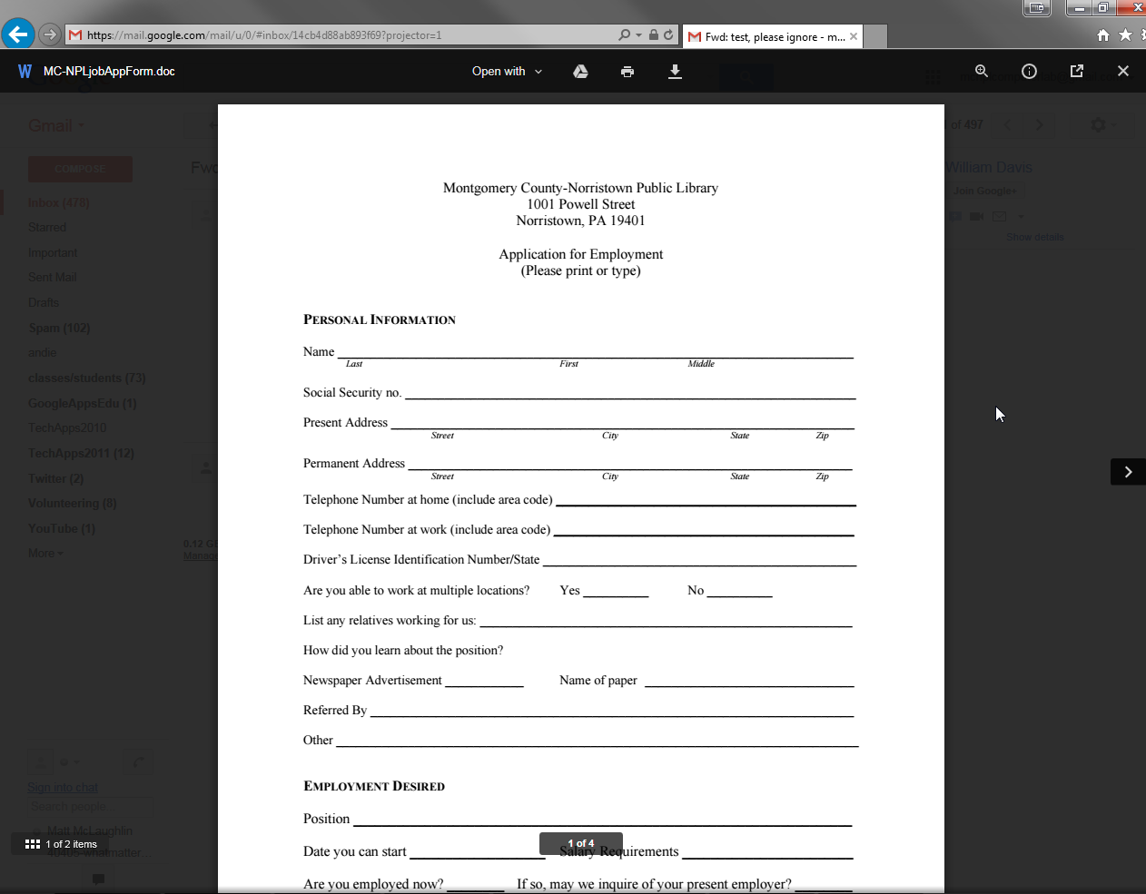

Click on “Open with” above the document, then select “DocHub”

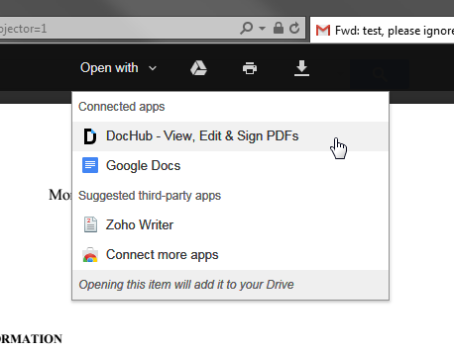
The patron will need to accept the agreement to allow DocHub to work with their gmail account

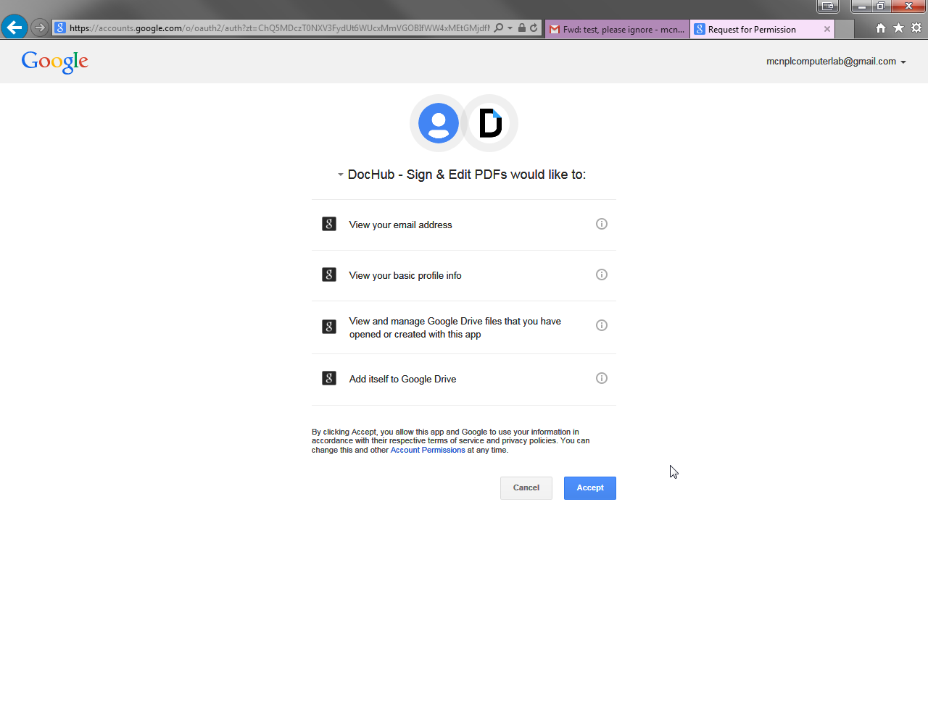
Once they accept, the document should open within the DocHub app. It may not work the first time, so If it doesn’t, just repeat the previous steps.

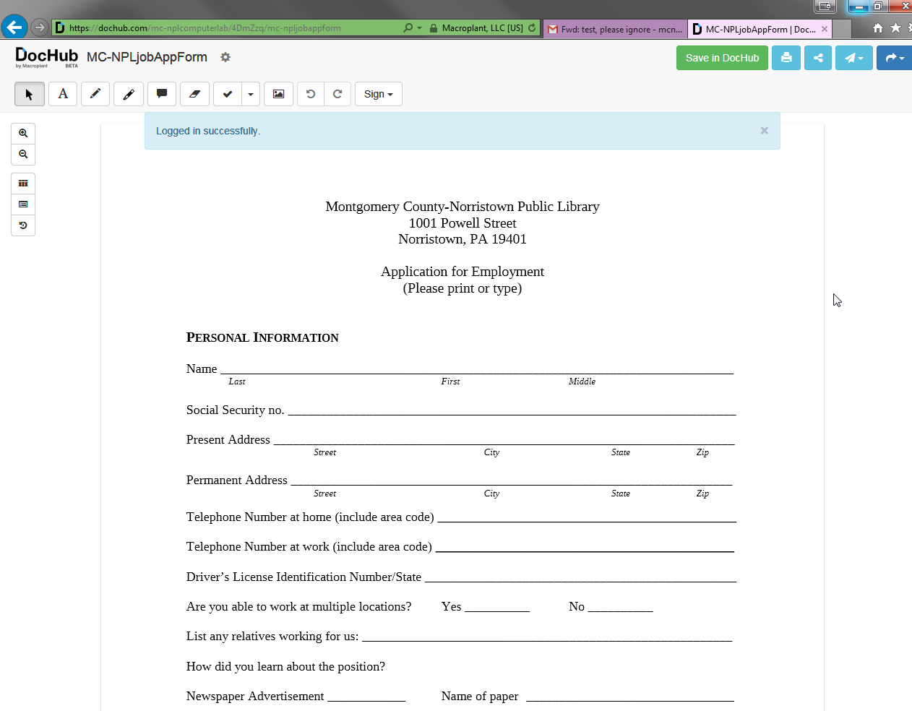

Navigate to the page you want to sign, then click on the “Sign” button in the menu bar, and select “Create or Import Signature”

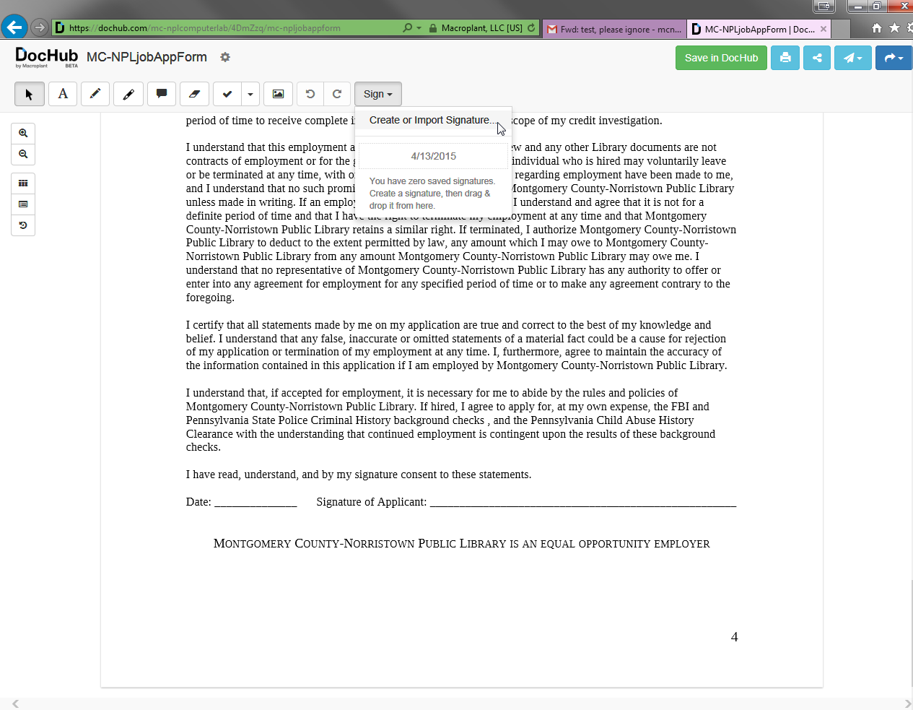
A prompt will appear where you can use your mouse to draw your signature. If the patron has a smart phone, they can draw their signature on it, and send it to the app to be saved. We will just be using the mouse for this example. Click save when you are complete

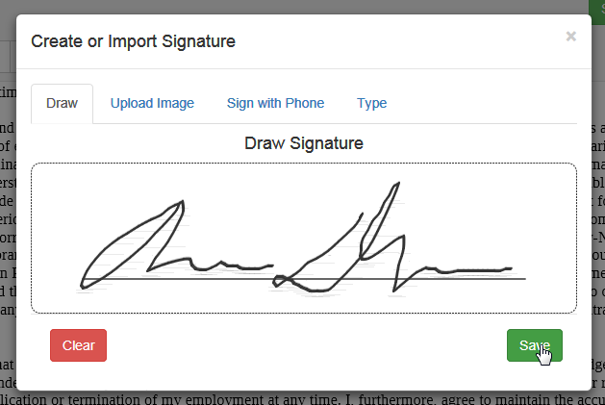

Click on the “Sign” button again, and then click and drag on the newly created signature

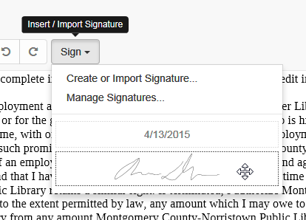
Drop the signature where you would like it.

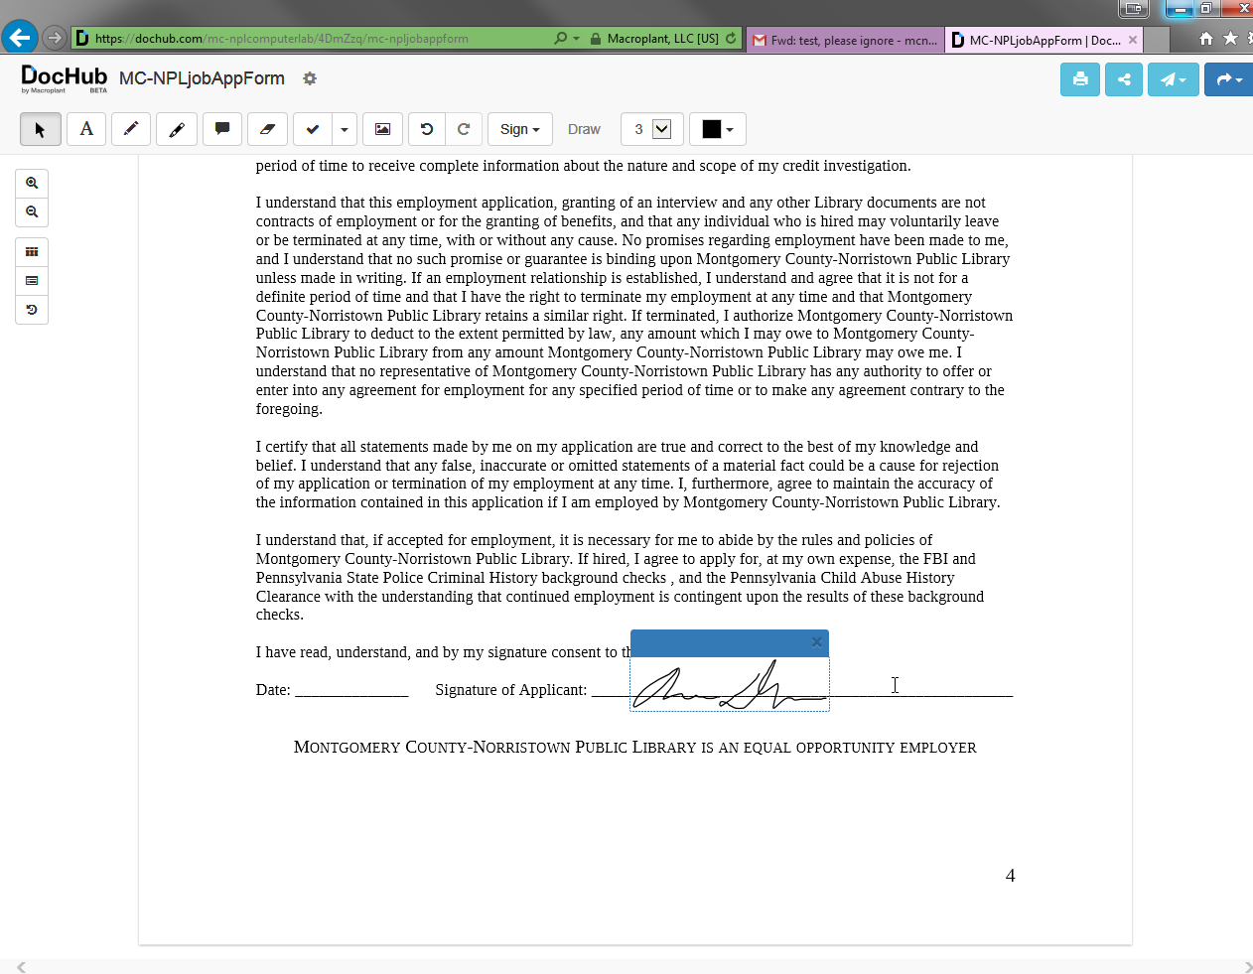
It will appear as a box that you can now resize and position to where you want it

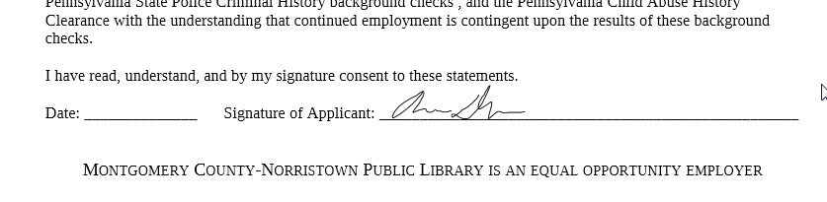
If you wish to insert a date, or additional typed text, click on the “Insert Text” button in the upper left

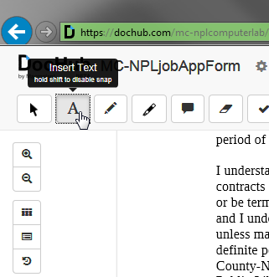

And then click where you would like to insert text. A new box will appear where you can enter your text. This box can also be repositioned.

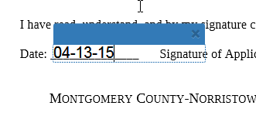
When you are finished, and you want to send the document, you can either click the paper airplane icon and click “Email as Attachment” to send a new email to a specified recipient

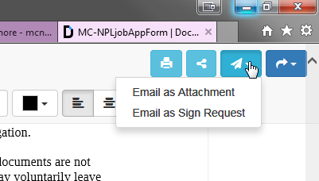

Or click on the arrow in the upper right, and click “Download PDF” and save the document to the temporary patron drive, where it can then be attached later as a reply to the original sender requesting the signature

